Titantic Analysis

1. In this problem statement, we will find the average fare of each class.

**Commands**

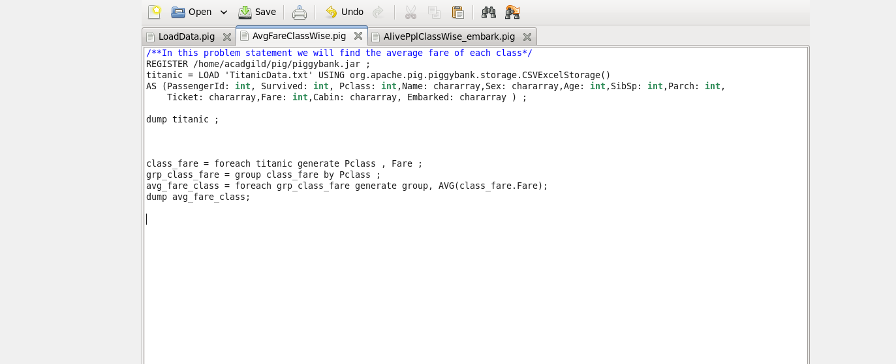

**Results**

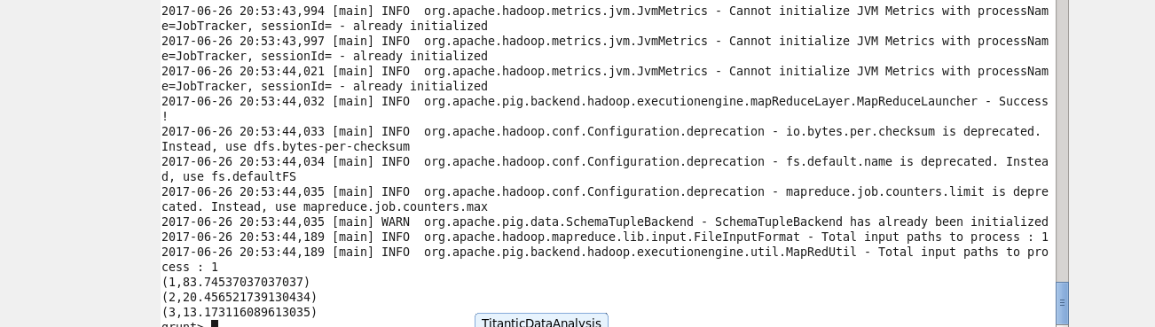

1. In this problem statement, we will find the number of people alive in each class and embarked at Southampton.

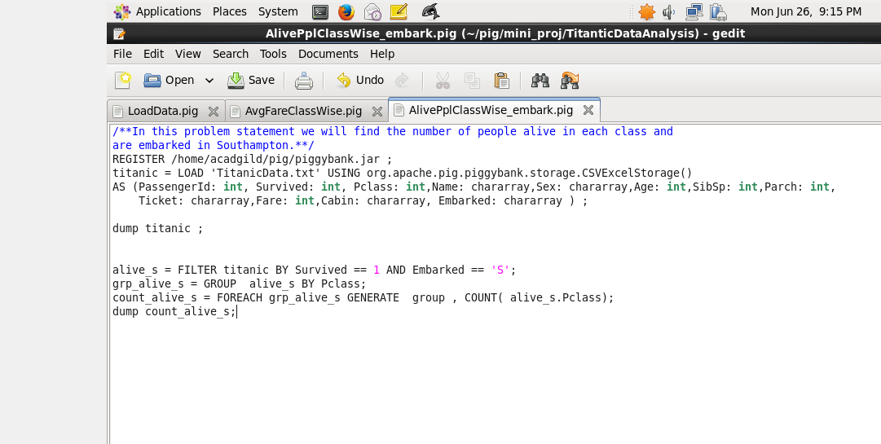

**Results**

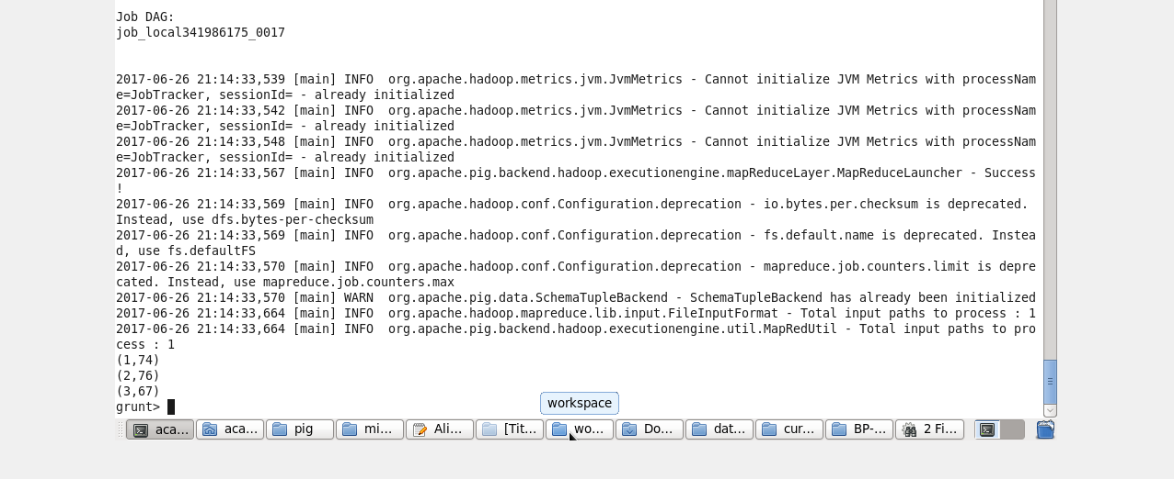

3 .In this problem statement, we will find out number of males and females who died in each class.

**Program**

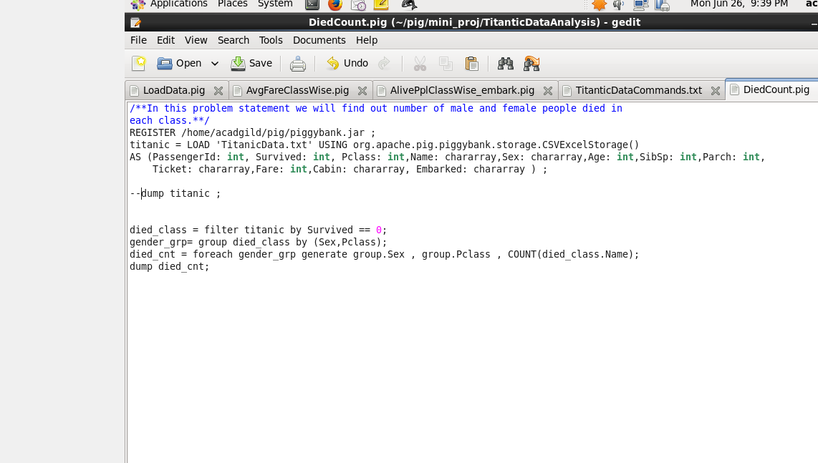

Result

